From: Alex Levitsky
To: Tiana Barnes, Sanjay Garg, Ned Lannister
Subject: UPDATE: Daylight Savings Post Performance
Hi Tiana, Sanjay, and Ned,

Congratulations on the successful launch of the new spring flavors! I am writing to update you on the performance of two posts we published around daylight saving time. The goal of this campaign was to increase audience engagement, so we looked at KPIs like reposts, replies, and likes.

Below are key findings from our analysis of the two posts:

- Post 1 was viewed nearly twice as many times as Post 2. Since Post 1 was posted at 8:03 a.m. and Post 2 was posted at 1:59 a.m., right before the time change, the difference in views was likely related to the time of day.
- Users engaged with Post 2 nearly six times as much as with Post 1, despite Post 2 having been viewed far less. Users may have been more inclined to engage with Post 2 because it contained a funny image, relevant hashtags, and text that they found more engaging. Post 1 did not contain any images or hashtags.

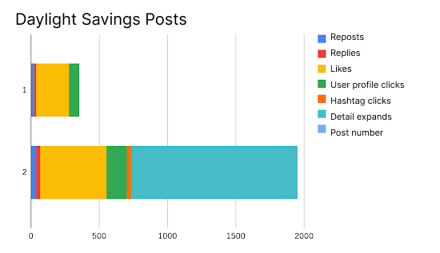

The data indicates that our audience on X engages more with posts containing images and hashtags, so we will include these components in future posrs. The data also suggests that humorous content resonates well with our audience, so we will implement more humor into future posts.

Please let me know if you’d like to discuss any of these findings further.

Best regards,

Alex

